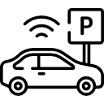 |  | PARKING RECEIPT
Address
[Contact Number]
 | Entry Time | 00/00/00 | 00:00 PM
 | Exit Time | 00/00/00 | 00:00 PM
 | Duration | 0d 1h 1m
 | Trans #: | 0000000
 | Ticket #: | 0000000
 | Total: $00.00
THANK YOU!
AND DRIVE SAFELY

